Project Report

***on***

**AI-Driven Knowledge Synthesis Platform**

***In partial fulfillment of requirements for the degree of***

**BACHELOR OF TECHNOLOGY IN**

**COMPUTER SCIENCE & ENGINEERING**

***Submitted by:***

Umang Goswami (22100BTCSAII11062) Shreyansh Gupta (22100BTCSAII11052) Naman Mathur (22100BTCSAII11027)

***Under the guidance of***

PROF. Neeraj Mehta



#### SHRI VAISHNAV VIDYAPEETH VISHWAVIDYALAYA, INDORE

**SHRI VAISHNAV INSTITUTE OF INFORMATION TECHNOLOGY**

**DEPARTMENT OF COMPUTER SCIENCE & ENGINEERING**

### January – June 2025

#### SHRI VAISHNAV VIDYAPEETH VISHWAVIDYALAYA, INDORE

**SHRI VAISHNAV INSTITUTE OF INFORMATION TECHNOLOGY**

**DEPARTMENT OF COMPUTER SCIENCE & ENGINEERING**

**DECLARATION**

We here declare that work which is being presented in the project entitled “**AI-Driven Knowledge Synthesis Platform**” in partial fulfillment of degree of **Bachelor of Technology** in **Computer Science & Engineering** is an authentic record of our work carried out under the supervision and guidance of **Professor Neeraj Mehta** of Computer Science & Engineering. The matter embodied in this project has not been submitted for the award of any other degree.

Umang Goswami Signature-

Shreyansh Gupta Signature-

Naman Mathur Signature-

Date:

#### SHRI VAISHNAV VIDYAPEETH VISHWAVIDYALAYA, INDORE

**SHRI VAISHNAV INSTITUTE OF INFORMATION TECHNOLOGY**

**DEPARTMENT OF COMPUTER SCIENCE & ENGINEERING**

**PROJECT APPROVAL SHEET**

The following team has done the appropriate work related to the “**AI-Driven Knowledge Synthesis Platform**” in partial fulfillment for the award of **Bachelor of Technology** in **Computer Science & Engineering** of “SHRI VAISHNAV INSTITUTE OF INFORMATION TECHNOLOGY” and is being submitted to SHRI VAISHNAV VIDYAPEETH VISHWAVIDYALAYA, INDORE.

**Team:**

1. **Umang Goswami**
2. **Shreyansh Gupta**
3. **Naman Mathur**

**Internal Examiner External Examiner**

Date

#### SHRI VAISHNAV VIDYAPEETH VISHWAVIDYALAYA, INDORE

**SHRI VAISHNAV INSTITUTE OF INFORMATION TECHNOLOGY**

**DEPARTMENT OF COMPUTER SCIENCE & ENGINEERING**

**CERTIFICATE**

This is to certify that **Mr. Umang Goswami**, **Mr. Shreyansh Gupta** and **Mr. Naman Mathur** working in a team have satisfactorily completed the project entitled “**AI-Driven Knowledge Synthesis Platform**” under the guidance of Mr. Prof. Neeraj Mehta in the partial fulfillment of the degree of **Bachelor of Technology** in **Computer Science & Engineering** awarded by SHRI VAISHNAV INSTITUTE OF INFORMATION TECHNOLOGY affiliated to SHRI

VAISHNAV VIDYAPEETH VISHWAVIDYALAYA, INDORE during the academic year **Jan- June 25**.

|  |  |
| --- | --- |
| Mr Neeraj Mehta |  |
| **Project Guide** | Mr. Vishwas Dixit |
|  | **Project Coordinator** |

Dr. Anand Rajavat

**Director & Head, Department of Computer Science & Engineering**

### ACKNOWLEDGEMENT

We are grateful to a number of persons for their advice and support during the time of complete our project work. First and foremost our thanks goes to **Dr. Anand Rajavat** Head of the Department of Computer Science & Engineering and **Mr. Neeraj Mehta** the mentor of our project for providing us valuable support and necessary help whenever required and also helping us explore new technologies by the help of their technical expertise. His direction, supervision and constructive criticism were indeed the source of inspiration for us.

We would also like to express our sincere gratitude towards our Director **Dr. Anand Rajavat**

for providing us valuable support.

We are really indebted to **Mr. Vishwas Dixit ,** project coordinator for helping us in each aspect of our academics activities. We also owe our sincere thanks to all the **faculty members** of Computer Science & Engineering Department who have always been helpful.

We forward our sincere thanks to all **teaching and non-teaching staff** of Computer Science & Engineering department, SVVV Indore for providing necessary information and there kind co- operation.

We would like to thanks our parents and family members, our classmates and our friends for their motivation and there valuable suggestion during the project. Last, but not the least, we thank all those people, who have helped us directly or indirectly in accomplishing this work. It has been a privilege to study at SHRI VAISHNAV VIDYAPEETH VISHWAVIDYALAYA, INDORE.

### Abstract

The AI-Driven Knowledge Synthesis Platform automates the transformation of unstructured data—such as PDFs, e-books, spreadsheets, and web articles—into structured, multimodal outputs including summaries, quizzes, flashcards, and podcasts. Leveraging Retrieval-Augmented Generation (RAG) pipelines, LangChain orchestration, and transformer-based NLP models, the platform enables dynamic cross-document knowledge synthesis tailored to user roles like students, educators, and professionals. It utilizes semantic embeddings stored in a FAISS vector database for accurate and efficient retrieval. The system features a Gradio- based web interface, Python backend, and cloud deployment via Microsoft Azure. Designed for scalability, personalization, and automation, it significantly reduces manual content curation time, enhances learning and training outcomes, and supports educational institutions and corporate environments with customizable AI-generated content.

#### LIST OF FIGURES

|  |  |  |
| --- | --- | --- |
| **Figure No.** | **Title** | **Page**  **No.** |
| Fig 4.1 | Use Case Diagram | 28 |
| Fig 4.2 | Conceptual Class Diagram | 29 |
| Fig 4.3 | Activity Diagram | 30 |
| Fig 4.4 | Data Flow Diagram  - Level 0 | 31 |
| Fig 4.5 | Data Flow Diagram  - Level 1 | 32 |
| Fig 4.6 | Data Flow Diagram  - Level 2 | 32 |
| Fig 4.7 | ER Diagram | 34 |
| Fig 5.1 | Detailed Class Diagram | 35 |
| Fig 5.2.1 | Sequence Diagram | 36 |
| Fig 5.3 | Collaboration Diagram | 37 |
| Fig 5.4 | State Diagram | 37 |
| Fig 5.5 | Activity Diagram | 38 |

Declaration

Project Approval Sheet Certificate Acknowledgment Abstract

List of Figures

CHAPTER 1 – **INTRODUCTION**

* 1. Introduction
  2. Problem Statement
  3. Need for the proper System
  4. Objective
  5. Modules of the system
  6. Scope

**TABLE OF CONTENT**

I II III IV V

VI 1-12

10

11

11

12

12

12

CHAPTER 2 - **LITERATURE SURVEY**

* 1. Existing System
  2. Proposed System
  3. Feasibility Study
     1. Technical Feasibility
     2. Economical Feasibility
     3. Operational Feasibility

CHAPTER 3 – **REQUIREMENTS ANALYSIS**

* 1. Method used for Requirement analysis
  2. Data Requirements
  3. Functional Requirements
  4. Non Functional Requirements
  5. System Specification
     1. Hardware specification
     2. Software Specification CHAPTER 4 – **DESIGN**
  6. Software Requirements Specification
     1. Glossary
     2. Supplementary Specifications
     3. Use Case Model
  7. Conceptual level class diagram
  8. Conceptual level activity diagram
  9. Data flow Diagram( Level 0,1,2)
  10. Database Design (ER-Diagram)

13-16

13

13

14

15.

15

15

16-23

16

16

17

18

20

21

22

23

24-33

24.

26

28

30

31

32

33

|  |  |  |
| --- | --- | --- |
| CHAPTER 5 – **SYSTEM MODELING** | | 34-42 |
| 5.1 | Detailed Class Diagram | 34 |
| 5.2 | Interaction Diagram | 35 |
|  | 5.2.1 Sequence Diagram | 35 |
|  | 5.2.2 Collaboration Diagram | 36 |
| 5.3 | State Diagram | 38 |
| 5.4 | Activity Diagram | 39 |
| 5.5 | Object Diagram | 40 |
| 5.6 | Component Diagram | 41 |
| 5.7 | Deployment Diagram  Testing | 42 |
| CHAPTER 6 – **CONCLUSION & FUTURE WORK** | | 43-44 |
| 6.1 | Limitation of Project | 43 |
| 6.2 | Future Enhancement | 43 |
| CHAPTER 7 - **BIBLIOGRAPHY & REFERENCES** | | 45 |

* 1. Reference Books
  2. Other Documentations & Resources
  3. Snapshot (with description)

# Chapter 1: Introduction

## Introduction

In today’s data-driven world, organizations are inundated with vast amounts of unstructured digital documents — including PDFs, spreadsheets, presentations, and reports — stored across different platforms and in multiple formats. Manually searching, extracting, and synthesizing meaningful information from this data is time-consuming and inefficient. The evolution of Natural Language Processing (NLP), semantic search, and vector databases has made it possible to build intelligent systems that understand and retrieve relevant information with human-like efficiency.

This project presents the development of a **Document Understanding and Retrieval System** using state-of-the-art AI frameworks like LangChain and vector databases such as FAISS, deployed and scaled on Azure cloud infrastructure. The system ingests multiple file formats, parses them into semantic chunks, embeds them into vector space, and performs retrieval- augmented generation (RAG) to answer queries intelligently.

The need for such a system is evident in enterprise settings, academic environments, legal research, and even personal productivity tools. This project aims to provide a modular, cloud-scalable solution that automates the ingestion, chunking, embedding, and retrieval of documents, producing contextual responses in real time.

This report details the entire system design, from requirement analysis and architecture to UML diagrams, deployment models, and future scope. It also evaluates the system’s performance on parameters like speed, scalability, and usability.

.

## Problem Statement

Organizations and users regularly deal with unstructured documents in formats like PDFs, Word files, presentations, and spreadsheets. Extracting relevant information or answering specific questions from such documents remains a manual and inefficient task. Traditional keyword-based search engines often fail to grasp the semantic context, leading to poor results.

There is a pressing need for an AI-powered system that can intelligently understand document content, chunk it into meaningful segments, and store it in a format that supports fast, context-aware retrieval. The system should not only fetch relevant segments but also generate human-like responses based on the retrieved context.

This project addresses the problem by building a scalable Document Understanding and Retrieval System that leverages semantic embeddings, retrieval-augmented generation (RAG), and multimodal output synthesis — all deployed on cloud infrastructure to ensure performance, scalability, and availability.

.

## Objective

* Automate content extraction from unstructured documents.
* Generate multimodal outputs like quizzes, summaries, flashcards, and podcasts.
* Enable cross-document synthesis and personalization.
* Support scalable deployment for institutions and enterprises.

## Modules of the System

* Document Ingestion
* Knowledge Extraction
* Cross-Document Retrieval

## Scope

The scope of this project encompasses the design, development, and deployment of an AI-powered document understanding system using a Retrieval-Augmented Generation (RAG) pipeline. The system is built to handle diverse document formats including PDFs, spreadsheets, and presentation slides, and enables end- to-end semantic search and synthesis capabilities.

Key components include:

* Document Ingestion: Upload and preprocess multiple document types from users.
* Semantic Chunking: Parse documents into meaningful text segments using natural language processing (NLP).
* Vector Embedding and Storage: Generate and store semantic embeddings in a FAISS vector database for efficient retrieval.
* Query Processing & Retrieval: Accept user queries and retrieve contextually relevant document segments using a RAG architecture.
* Response Generation: Use generative AI models to synthesize coherent, informative, and multimodal responses.
* Cloud Deployment: Implement the entire system on Microsoft Azure with features such as auto-scaling, caching, load-balancing, and high availability.

The system is designed to support scalability, fast response time (<3 seconds), and robust performance for enterprise-grade applications like knowledge management, research automation, legal document analysis, and customer support.

# Chapter 2: Literature Survey

## Existing System

In recent years, the integration of artificial intelligence in education and productivity platforms has seen a rise. However, most of the existing systems offer limited and fragmented functionalities. For instance:

* **Quizlet**, a widely used platform, enables users to create flashcards manually. While it supports learning through spaced repetition and collaborative usage, it is heavily dependent on user-generated content and lacks any advanced automation or AI-based synthesis capabilities.
* **Grammarly**, another prevalent tool, focuses primarily on grammar checking and language refinement. Although powered by NLP techniques, its scope is narrowly limited to writing enhancement and does not cater to knowledge extraction or multimodal content creation.

Furthermore, traditional document summarization tools are generally single- format focused and lack the capability to process and integrate information across multiple types of documents such as PDFs, spreadsheets, and web pages.

##### Limitations in Existing Systems:x

* No support for **cross-format knowledge synthesis**.

##### Lack of personalized or dynamic output generation.

* Minimal or no use of advanced **AI-based document retrieval and synthesis pipelines**.
* Outputs are either static or user-dependent with little automation.

.

## Proposed System

The proposed system, for **AI-Driven Knowledge Synthesis Platform**, is an intelligent, cloud-based solution designed to automate the process of document understanding, knowledge extraction, and multimodal output generation. Unlike traditional tools that operate in silos—such as basic summarizers, grammar checkers, or flashcard creators—this platform offers a unified workflow powered by advanced Natural Language Processing (NLP) and Retrieval-Augmented Generation (RAG) techniques.

At its core, the system allows users to upload various types of documents including PDFs, spreadsheets, and presentations. These documents are parsed and semantically broken down into meaningful chunks using models orchestrated by LangChain. Each chunk is transformed into a high-dimensional embedding vector and stored in a FAISS vector database, enabling context-aware semantic search. When a user submits a query, the system retrieves the most relevant document segments using both keyword and vector similarity, and passes them through a generative language model to create human-like responses.

What sets this system apart is its ability to generate multimodal outputs—including textual summaries, quizzes, flashcards, and podcasts—tailored to different user roles such as students, educators, or corporate professionals. The entire application is containerized using Docker and deployed on Microsoft Azure, ensuring scalability, high availability, and ease of integration into institutional or enterprise environments. This proposed system thus addresses a critical gap in intelligent document processing and stands as a comprehensive, user-friendly, and scalable solution for modern knowledge management needs.

##### Core Highlights:

* **Document Parsing**: Ingests and converts diverse formats like PDFs, spreadsheets, e-books, and web articles into structured data.
* **Retrieval-Augmented Generation (RAG)**: Uses semantic and keyword-based search to fetch relevant chunks from a document base, enabling high-quality content generation.
* **Multimodal Output Generation**: Automatically creates summaries, quizzes, flashcards, and even audio-based outputs (like podcasts) based on user needs.

The platform offers personalization through role-based output generation and ensures scalability via cloud deployment. Unlike existing tools, it leverages **vector databases (FAISS)**, **LangChain orchestration**, and **transformer-based NLP models** to provide a robust end-to-end solution.

## Feasibility Study

Feasibility analysis determines the viability of implementing the proposed system from multiple dimensions:

##### Technical Feasibility

The system leverages proven, open-source and cloud-compatible technologies:

* + - * **Transformers** from Hugging Face for embedding and generation tasks.
      * **LangChain**, which allows seamless orchestration of RAG pipelines.
      * **Vector databases (FAISS)** for fast, similarity-based content retrieval.
      * The backend is developed in **Python**, ensuring compatibility with popular AI frameworks.
      * Frontend is built using **Gradio** for fast and interactive user interfaces.

These tools are **mature**, **well-supported**, and **capable of handling real-time data**

processing and transformation.

##### Economic Feasibility

* + - * **Deployment via Microsoft Azure** offers a flexible pricing model with pay-as- you-go plans, making it cost-efficient for academic institutions and startups.
      * Open-source libraries and frameworks minimize initial development and licensing costs.

Containerization using **Docker** enables portability and reduces infrastructure related expenditures.

Thus, from a cost-benefit perspective, the system is economically viable for small teams and scalable enough for enterprise environments.

##### Operational Feasibility

* + - * The interface is intuitive and accessible via a standard web browser, requiring no installation.
      * Built using **Gradio**, it supports interactive document uploads, role-based personalization, and easy navigation.
      * Since outputs are generated automatically using AI pipelines, users (educators, students, professionals) can benefit without requiring any technical background.

This makes the system practical and easy to integrate into **existing academic and corporate workflows**, ensuring high user acceptance and minimal learning curve.

.

# Chapter 3: Requirements Analysis

## Requirement Analysis Method

The requirement analysis for this project was carried out using a combination of interviews, observation, and document analysis to thoroughly understand user needs and system expectations. The approach included the following steps:

1. Stakeholder Identification:

* Identified key stakeholders such as end-users (students, researchers), system administrators, and technical teams involved in implementation.

1. Requirement Gathering Techniques:

* Interviews & Questionnaires: Conducted structured discussions with users to gather expectations about functionalities like document upload, search accuracy, response time, and system accessibility.
* Document Study: Reviewed technical papers and similar existing platforms to define benchmark features and non-functional needs.
* Observation: Simulated scenarios of document processing and query interactions to understand pain points and usability gaps.

1. Requirement Categorization:

* Clearly distinguished between Functional Requirements (FR) and Non-Functional Requirements (NFR).
* Each requirement was mapped to its corresponding system module to ensure traceability.

1. Validation and Verification:

* Requirements were verified against stakeholder feedback and validated for technical feasibility with the proposed technology stack (LangChain, FAISS, Azure).

1. Tools and Documentation:

* Used Requirement Traceability Matrix (RTM) to ensure each requirement is addressed during design and implementation.

## Data Requirements

* Input: PDFs, Word documents, spreadsheets, e-books.
* Output: Summaries, Flashcards, Quizzes, Podcasts.

## Functional Requirements

Functional requirements define the core behavior and capabilities that the system must offer to its users. These features are integral to the operation of the **AI-Driven Knowledge Synthesis Platform** and are aligned with the system’s objectives of enabling automated, multimodal knowledge synthesis.

Below is a detailed list of the functional requirements:

##### Document Upload and Ingestion

* + - * The system shall allow users to upload documents in various formats such as:
        + PDF
        + DOCX
        + Excel sheets (XLSX/CSV)
        + PowerPoint presentations (PPTX)
        + E-books (EPUB)
        + Web articles (via URL input)
      * Uploaded documents shall be stored temporarily for processing and retrieval.

##### Document Parsing and Preprocessing

* + - * The platform shall extract raw text from uploaded documents using format- specific parsers.
      * Content shall be segmented into semantically meaningful chunks using LangChain’s document chunking pipeline.
      * Metadata such as title, author, and date shall be extracted where available.

##### Semantic Embedding and Storage

* + - * Each document chunk shall be converted into vector embeddings using pre-trained transformer models (e.g., BERT or Sentence-BERT).
      * These embeddings shall be stored in a FAISS-based vector database to support similarity-based searches.
      * The system shall ensure traceability by tagging each embedding with source document references.

##### Query Input and Cross-Document Retrieval

* + - * The system shall provide a query interface for users to input questions or topics of interest.
      * Upon query submission, the system shall:
        + Perform keyword matching and vector similarity search.
        + Retrieve the most relevant document chunks from across all uploaded documents.
      * The system shall present a ranked list of retrieved sources to ensure transparency.

##### Multimodal Content Generation

* + - * The platform shall dynamically generate output in multiple formats:
        + **Summaries**: Both extractive (keyword-based) and abstractive (language generation).
        + **Quizzes**: Auto-generated MCQs based on key concepts extracted from documents.
        + **Flashcards**: Generated in Q&A format for spaced-repetition learning.
        + **Podcasts**: Summarized content converted to speech using text-to- speech APIs.
      * Users shall be able to select their preferred output formats and languages.

##### Role-Based Personalization

* + - * The system shall allow users to select roles (e.g., Educator, Student, Professional).
      * Based on the selected role, output formatting, complexity, and tone shall be adapted.
        + For example, educators may receive presentation slides, while students receive summaries and flashcards.

##### User Authentication and Access Control

* + - * The system shall implement user authentication to support session-based access.
      * Different access privileges shall be defined based on roles:
        + Admin: Full access including user management and analytics.
        + General User: Upload, query, and view outputs.

##### Output Download and Sharing

* + - * Users shall be able to download generated outputs in popular formats:
        + Summaries and flashcards: PDF or DOCX
        + Quizzes: PDF or HTML
        + Podcasts: MP3 or WAV
      * Outputs shall be optionally shareable via unique public URLs.

##### Feedback Collection

* + - * The system shall offer feedback mechanisms to rate the accuracy and relevance of outputs.
      * This feedback shall be stored to improve future results via retraining or fine-tuning.

##### System Logs and Monitoring

* + - * All user activities (upload, query, generation) shall be logged for monitoring and analytics.
      * Admin users shall be able to view system usage reports and error logs via a dashboard.

## Non-Functional Requirements

Non-functional requirements define the performance characteristics, quality attributes, and constraints under which the system must operate. These requirements ensure that the system is usable, efficient, reliable, scalable, and secure, which are essential for both academic and professional adoption.

The non-functional requirements for the AI-Driven Knowledge Synthesis Platform are categorized as follows:

##### Performance Requirements

* + - * The system shall process user queries and generate responses within a maximum latency of **3 seconds** under normal load conditions.
      * Embedding generation and document parsing for a standard document (less than 10MB) shall complete within **5–8 seconds**.
      * Simultaneous processing of at least **20 concurrent users** shall be supported without degradation in performance on standard Azure VM configuration.

##### Scalability

* + - * The platform shall be horizontally scalable to accommodate increasing user loads, documents, and queries.
      * It shall support auto-scaling of compute resources in the cloud (Azure) during peak usage.
      * Modular architecture using microservices and containerization (via Docker) shall enable independent scaling of the document processing, embedding, retrieval, and generation modules.

##### Reliability and Availability

* + - * The system shall maintain **99.5% uptime**, ensuring high availability for users across different time zones.
      * All critical services shall be monitored using health checks, and failure recovery mechanisms (such as automatic restarts) shall be in place.
      * Azure’s distributed infrastructure shall be leveraged to ensure redundancy and failover support.

##### Usability

* + - * The user interface shall be intuitive, clean, and responsive, making it accessible to users with minimal technical expertise.
      * Instructions and tooltips shall be available for every major feature (e.g., file upload, output options).
      * The platform shall support **keyboard navigation**, **form validation**, and

**mobile responsiveness** for accessibility on tablets and smartphones.

##### Maintainability

* + - * The system architecture shall follow a modular structure, ensuring ease of updates and bug fixes.
      * Code shall adhere to standard coding conventions (e.g., PEP 8 for Python).
      * Version control shall be implemented via **Git**, with proper documentation for all modules to support collaborative development and future enhancement.

##### Portability

* + - * The application shall run in containerized environments and be deployable on any cloud platform (e.g., Azure, AWS, GCP) or on-premise system with Docker support.
      * It shall be accessible across all major web browsers (Chrome, Firefox, Edge, Safari).
      * No platform-specific features shall be hardcoded to ensure cross-platform compatibility.

##### Security Requirements

* + - * All data transmissions shall be encrypted using **HTTPS** with TLS 1.3.
      * Uploaded documents shall be sandboxed and removed from storage after processing to ensure data privacy.
      * Role-based access control (RBAC) shall be enforced to prevent unauthorized access to administrative functions.
      * Authentication tokens (JWT or OAuth2) shall be used to secure user sessions.
      * The system shall be regularly tested for vulnerabilities (e.g., XSS, CSRF, injection attacks).

##### Compliance and Data Privacy

* + - * The system shall comply with applicable data protection regulations (e.g.,

**GDPR**, **India’s DPDP Act**) by ensuring:

* + - * + No long-term storage of personal documents or user data unless explicitly consented.
        + Users can request deletion of their uploaded data at any time.

##### Localization and Language Support

* + - * The system shall support generation of outputs (summaries, quizzes, flashcards) in multiple languages (e.g., English, Hindi, Spanish) using multilingual models.
      * The UI text shall be translatable based on user preference, supporting basic localization features.

##### Auditability and Traceability

Every generated output (summary, quiz, podcast) shall be traceable to its

* + - * source document chunks through unique identifiers.
      * All user activities (uploads, queries, downloads) shall be logged with timestamps to support auditing.

## System Specifications

**Hardware-**

|  |  |
| --- | --- |
| **Component** | **Specification** |
| Processor | Intel Core i3 (10th Gen) or equivalent |
| Ram | 4 Gb |
| Hard disk | 256 Gb SSD |
| Network adapter | 802.11 b/g/n Wireless or Ethernet |
| Display | 720p resolution monitor |
| Input Devices | Standard Keyboard and Mouse |

**Software**

* Python, Flask, LangChain, HuggingFace Transformers, FAISS, Docker, Microsoft Azure

# Chapter 4 – Design

## Software Requirements Specification (SRS) Summary

The Software Requirements Specification (SRS) for the AI-Driven Knowledge Synthesis Platform serves as a comprehensive blueprint for the development of an intelligent system that automates the transformation of unstructured information into meaningful, multimodal content tailored for educational and professional use. This document encapsulates the platform’s purpose, functional behavior, system architecture, and quality constraints, while also providing a clear understanding of how it interacts with users and external systems.

The platform is designed to handle a variety of document formats, including PDFs, e-books, spreadsheets, presentations, and web articles. It employs advanced natural language processing models and retrieval-augmented generation (RAG) pipelines to extract, synthesize, and repurpose content into outputs such as summaries, quizzes, flashcards, and podcasts. These outputs are generated dynamically based on the user’s input and role, ensuring a personalized and context-aware experience. The system leverages technologies like LangChain for orchestration, Hugging Face Transformers for semantic understanding, and FAISS for efficient vector-based similarity searches. This ensures that content is not only retrieved accurately but also generated in a way that aligns with the user’s intent and learning objectives.

The SRS details how different user roles—including students, educators, professionals, and administrators—interact with the system. The user interface is designed to be minimal yet interactive, built using Gradio, and accessible via standard web browsers. The backend, powered by Python, manages document processing, vector embedding, query handling, and content generation. Processed data is stored in a vector database, enabling fast and accurate information retrieval across multiple document sources. The system architecture promotes modularity, which facilitates scalability, maintenance, and extensibility. The platform is containerized using Docker and deployed on Microsoft Azure, providing robust infrastructure support with features like auto-scaling, global availability, and built-in security protocols.

The SRS outlines several operational constraints, such as the need for cloud infrastructure, reliance on third-party APIs, and the assumption that input documents are in readable formats. It highlights the system’s ability to comply with data privacy standards, offering secure document handling, encrypted communications, and session-based user authentication. Additionally, the document addresses critical quality attributes such as performance (fast response times), reliability (minimal downtime), usability (ease of interaction for non-technical users), and maintainability (clean and modular codebase).

Expected outcomes of the system include a significant reduction in time and effort for manual content curation, improved accuracy in cross-document knowledge synthesis, and an engaging user experience through multimodal output delivery. This makes the platform especially useful for academic institutions aiming to automate course material creation, professionals compiling reports and training modules, and organizations managing large volumes of informational content. Overall, the SRS presents the AI-Driven Knowledge Synthesis Platform as a forward-thinking, AI-powered solution built to bridge the gap between unstructured knowledge sources and personalized, actionable insights.

This section reiterates the key functional and non-functional requirements identified in Chapter 3, and maps them to the high-level components of the system:

X`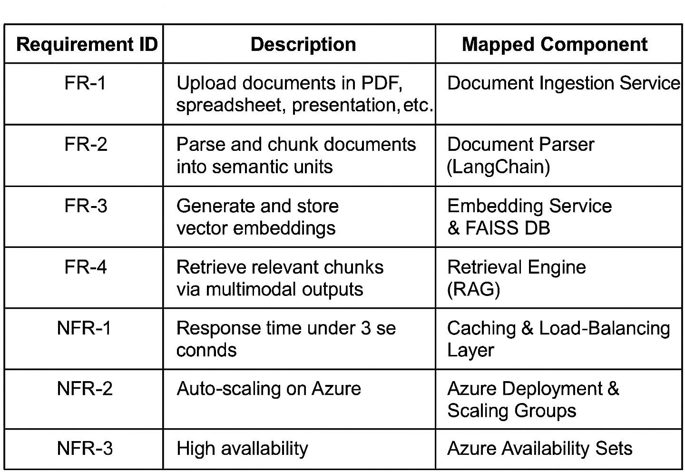

## Glossary

* + - **Chunk**: A semantically coherent segment of a document.
    - **Embedding**: A dense numerical vector representing semantic content.
    - **RAG (Retrieval-Augmented Generation)**: A framework combining retrieval of relevant text snippets with generative models.
    - **Multimodal Output**: Content generated in multiple formats (text, audio, flashcards).

## Supplementary Specifications

* + - **Security**: All document uploads and outputs are encrypted in transit via HTTPS; stored embeddings are encrypted at rest with Azure Key Vault.
    - **Accessibility**: The UI complies with WCAG 2.1 AA guidelines.
    - **Internationalization**: Supports English and Hindi localization.

## Use Case Model

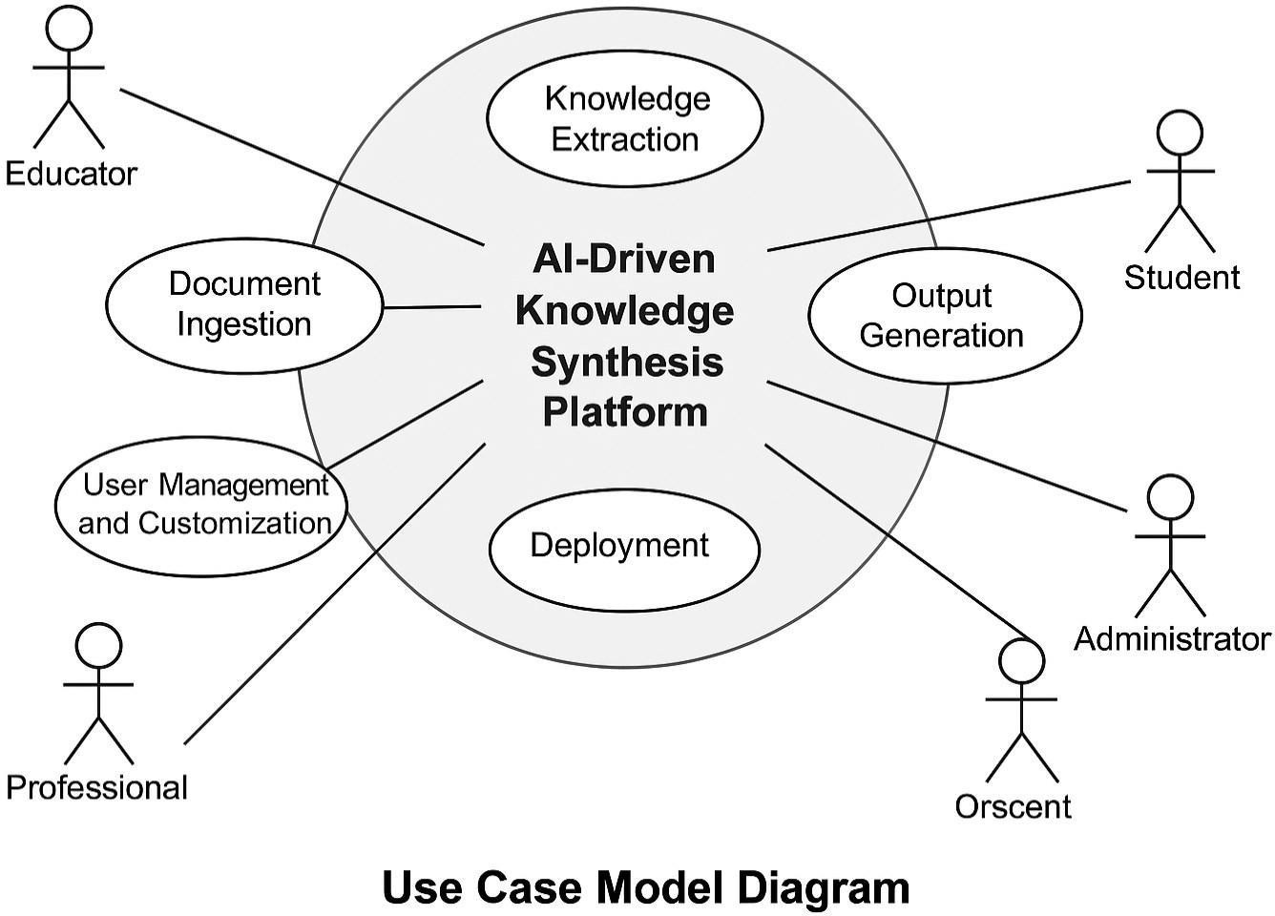

**Use Case Diagram** (Figure 4.1)

## Conceptual Class Diagram

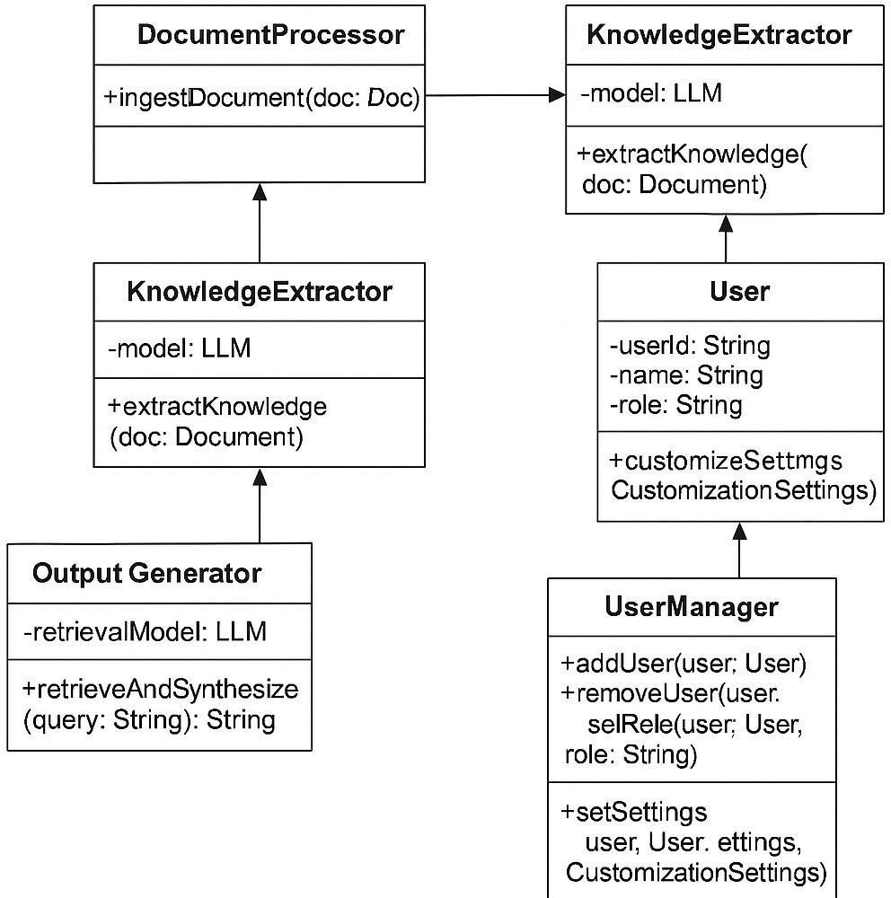

##### Figure 4.2 – Conceptual Class Diagram

## Conceptual Activity Diagram

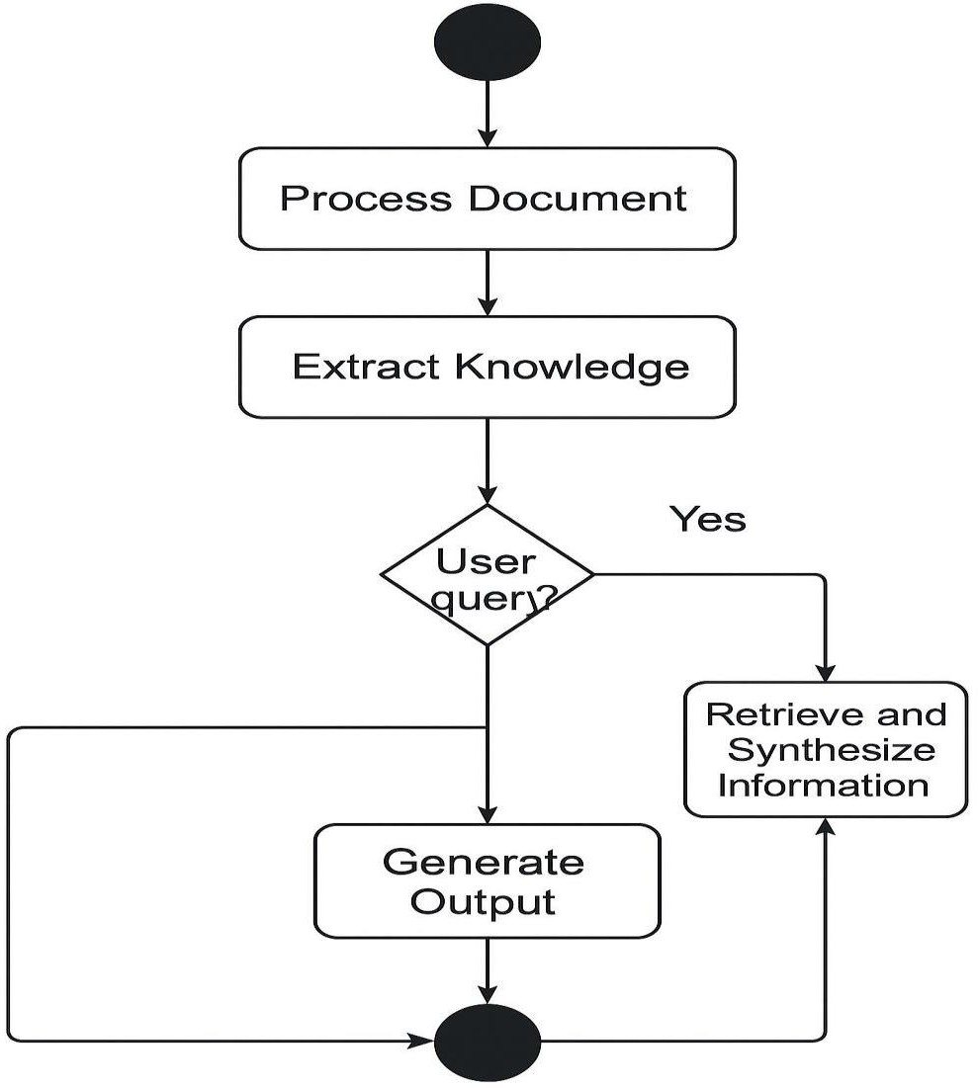

**Figure 4.3 – Activity Diagram**

## Data Flow Diagrams

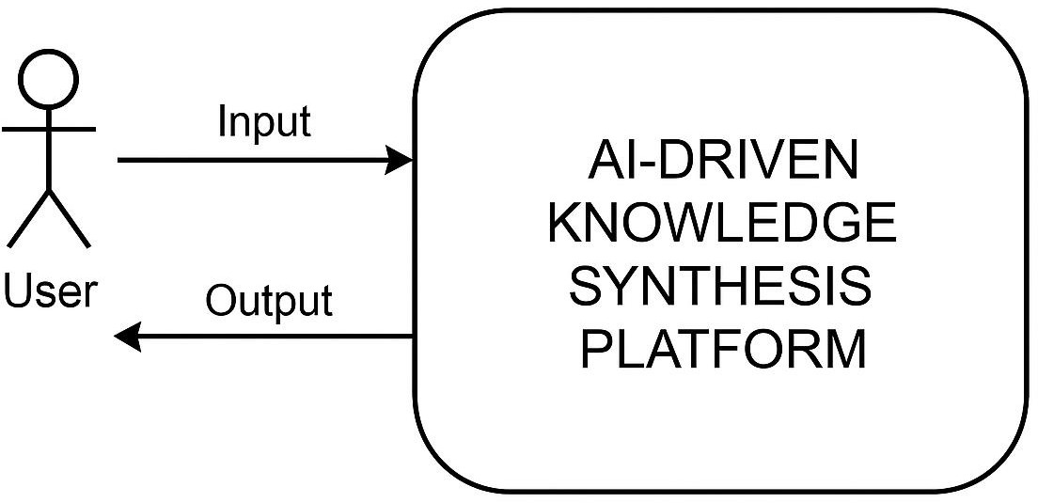

**DFD Level 0** (Figure4.4)

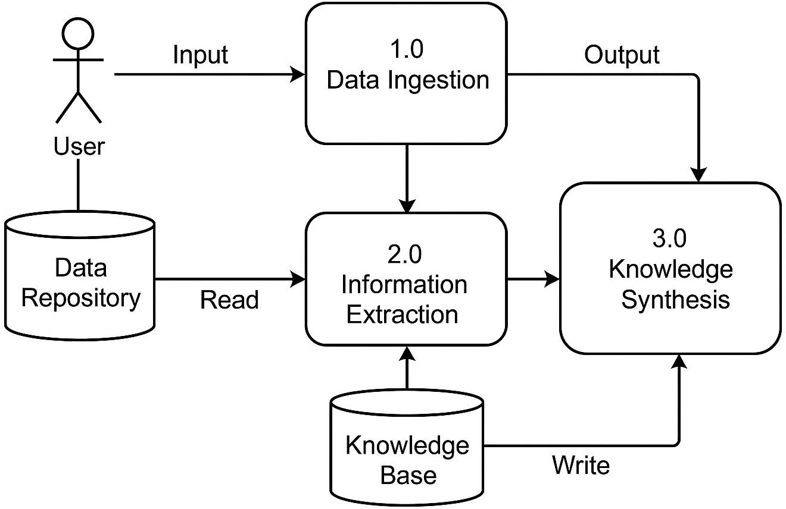

**DFD Level 1** (Figure 4.5)

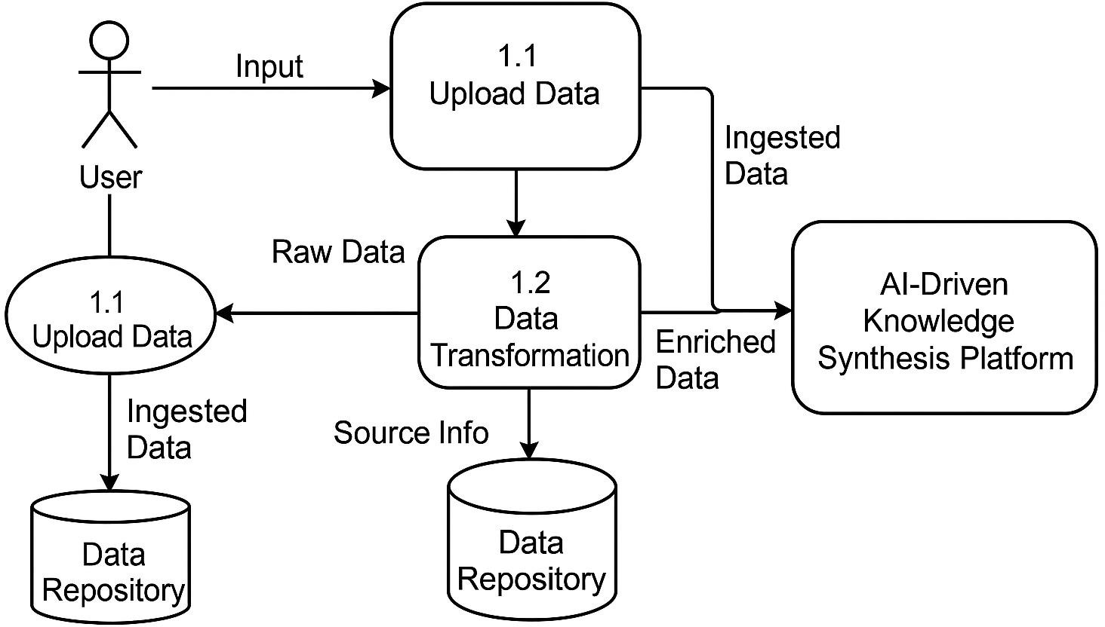

**DFD Level 2** (Figure 4.6)

## Database Design (ER Diagram)

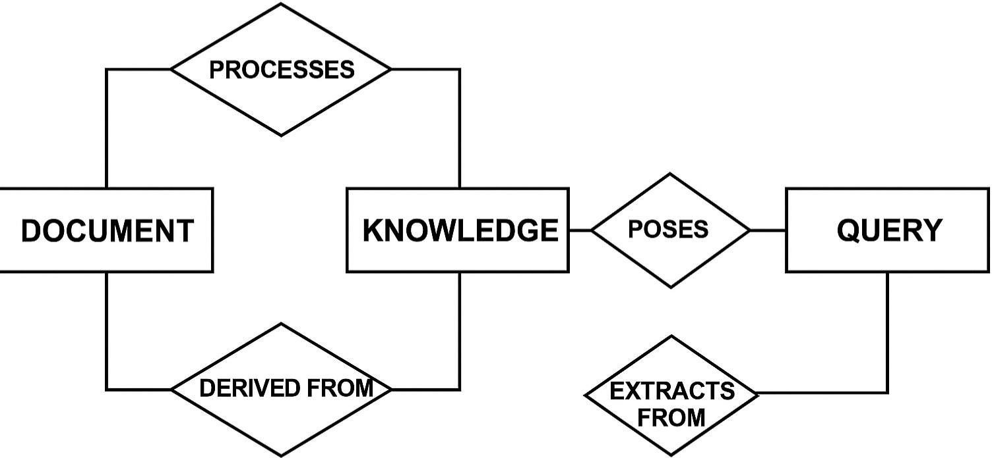

**Figure 4.7 – ER Diagram**

# Chapter 5 – System Modeling

## Detailed Class Diagram

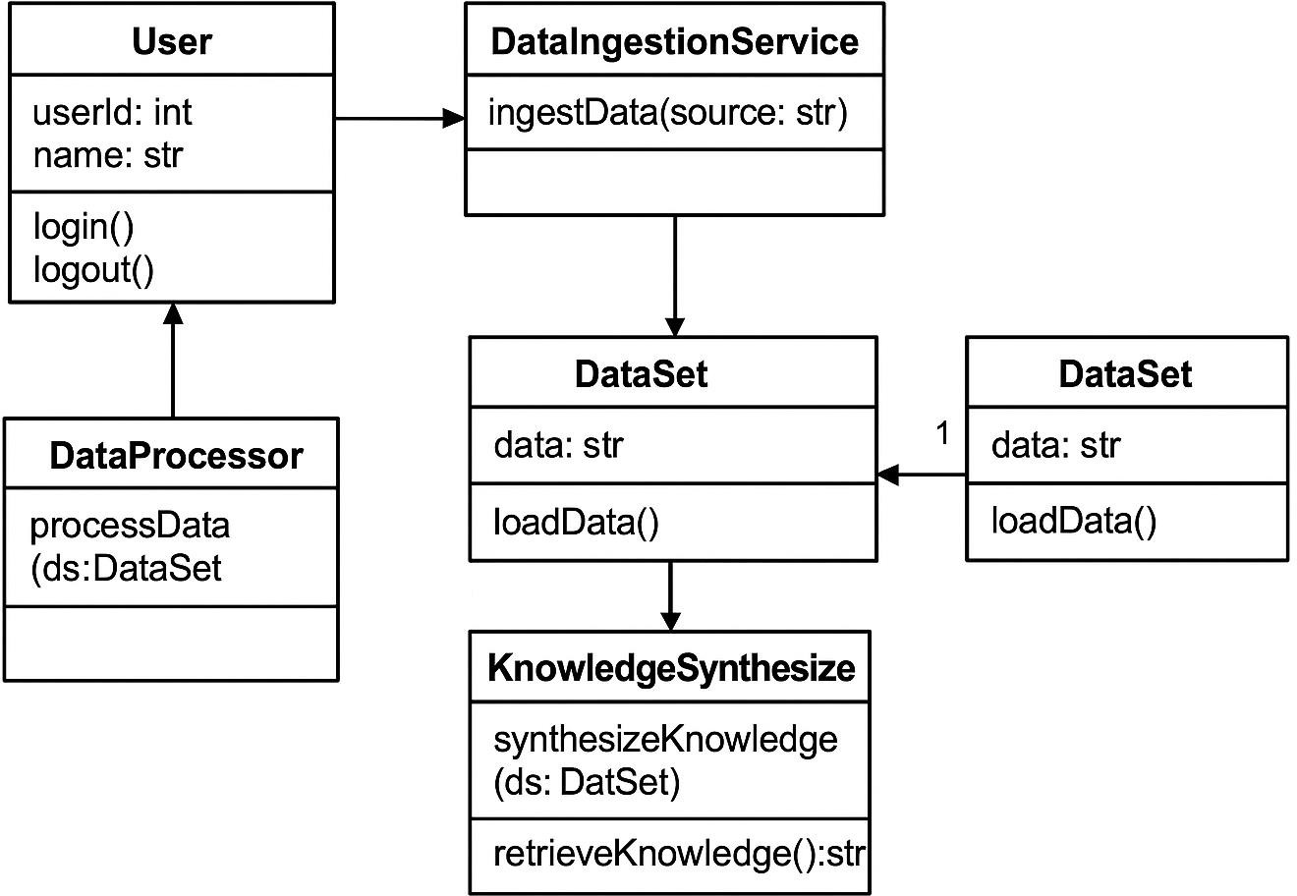

**Figure 5.1 – Detailed Class Diagram**

## Interaction Diagrams

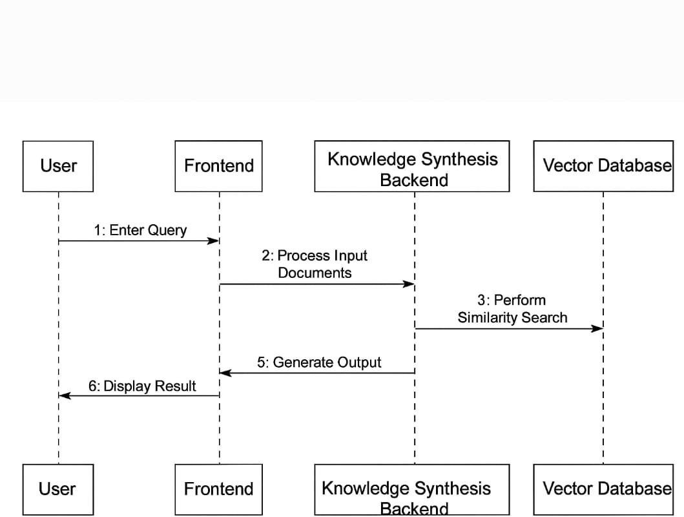

**Figure 5.2.1 – Sequence Diagram**

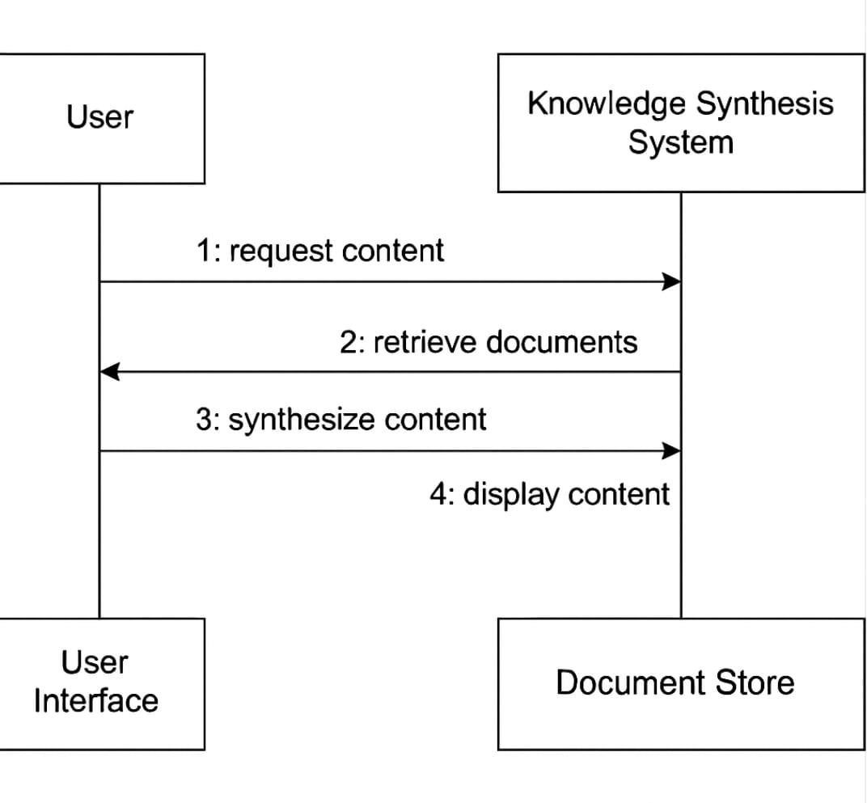

**Figure 5.3 – Collaboration Diagram**

## State Diagram

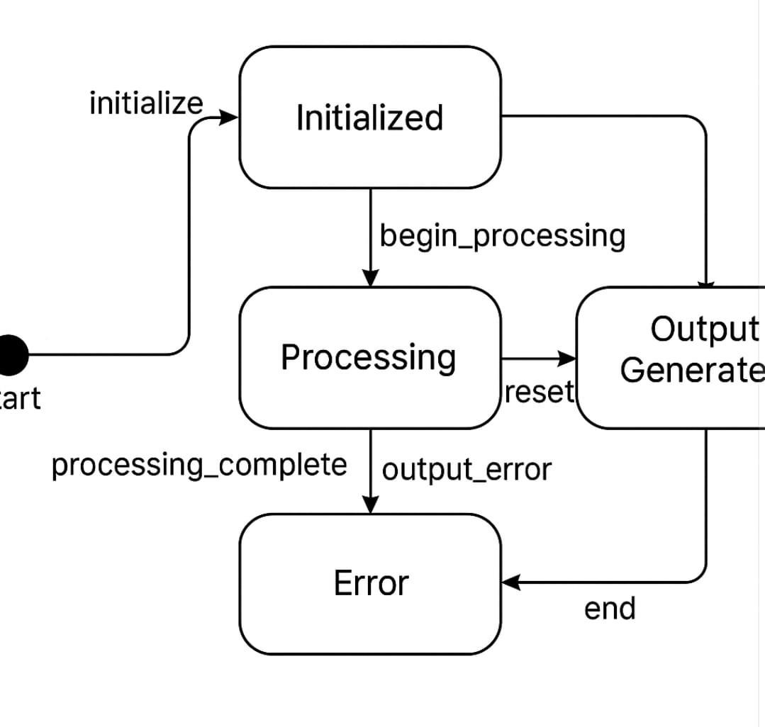

**Figure 5.4 – State Diagram**

## 5.5 Activity Diagram

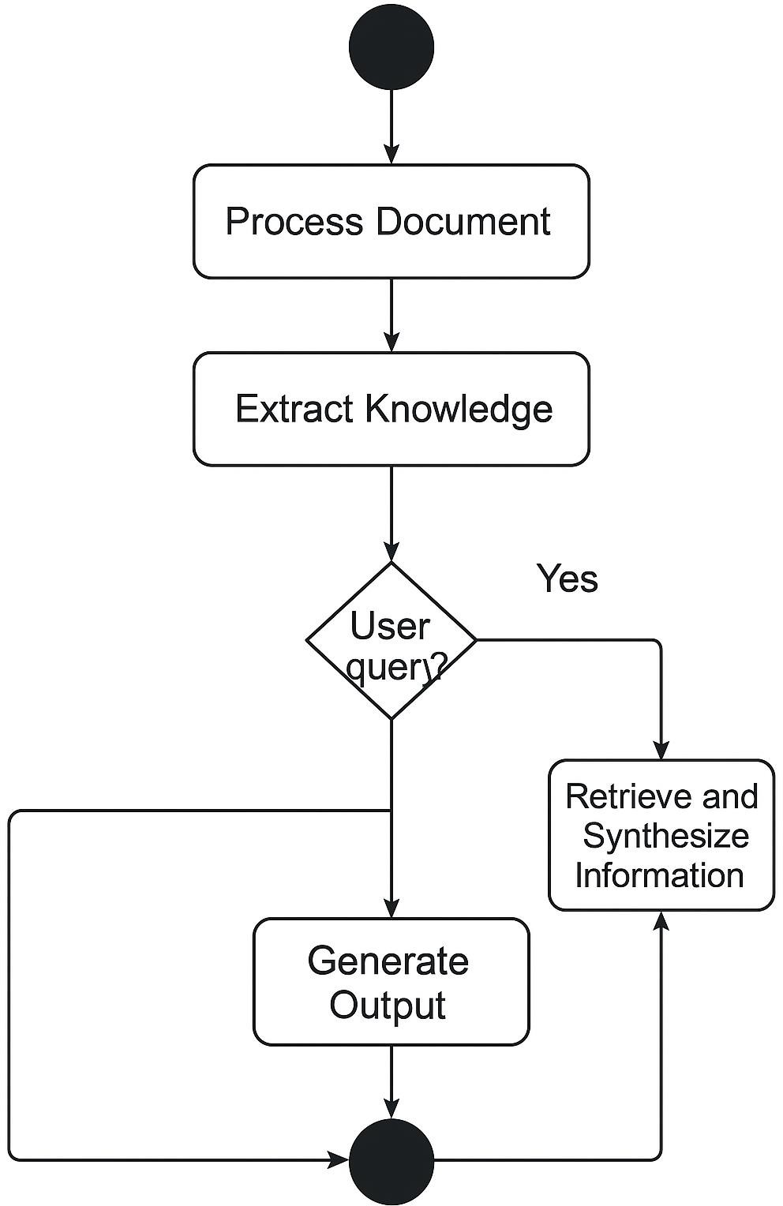

**Figure 5.5 – Activity Diagram**

## 5.6 Object Diagram

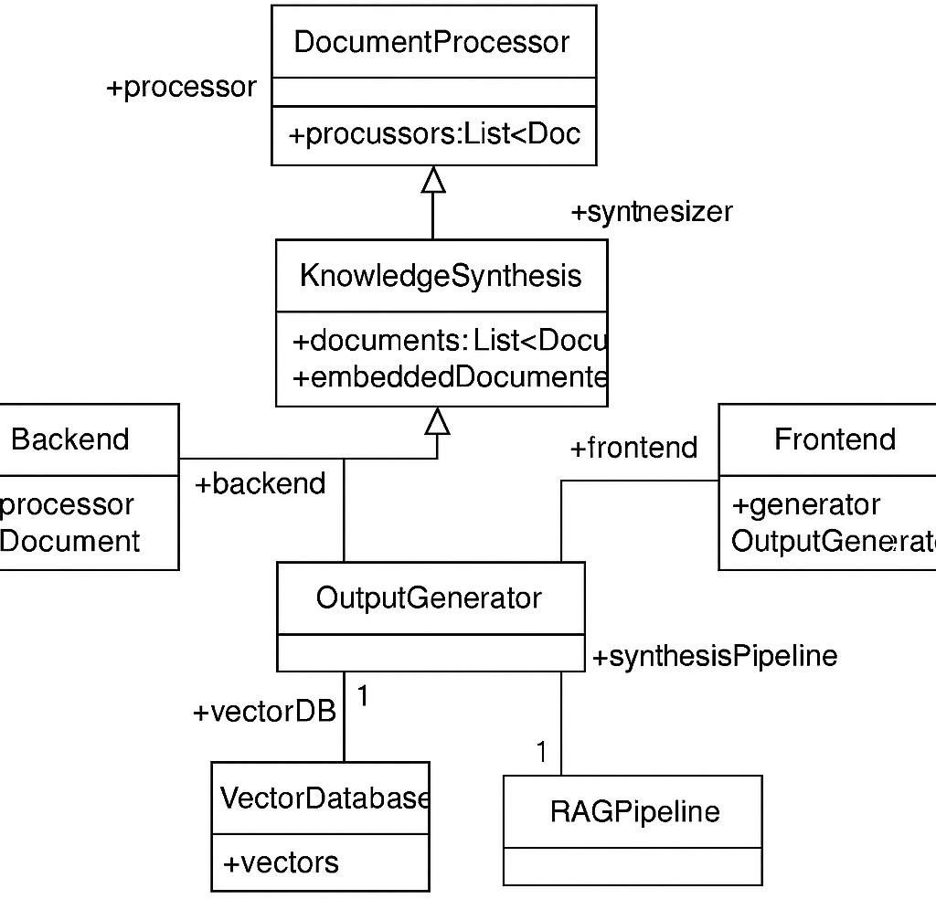

**Figure 5.6 – Object Diagram**

## 5.7 Component Diagram

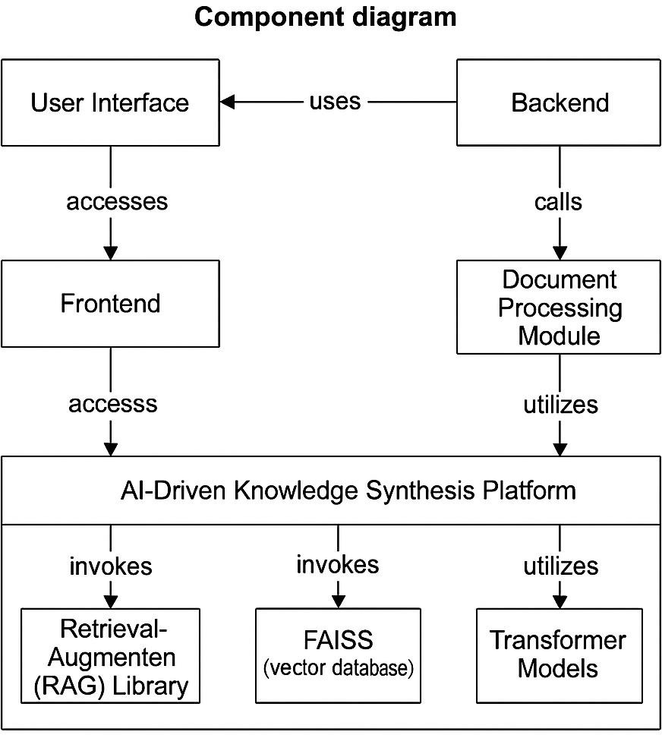

**Figure 5.7 – Component Diagram**

## 5.7 Deployment Diagram

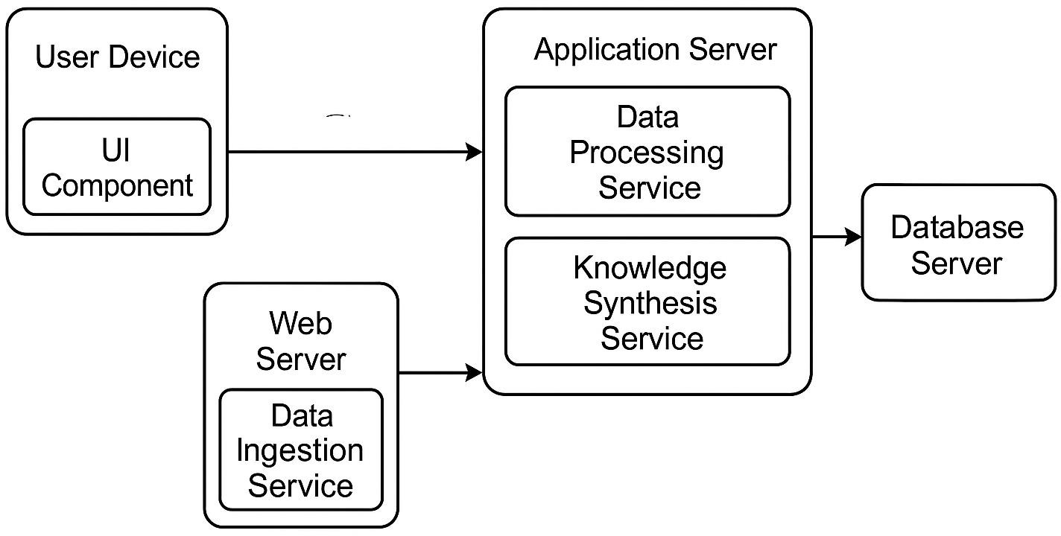

**Figure 5.8 – Deployment Diagram**

## 5.8Testing

* + 1. **Unit Testing**
* **DocumentParserTests**: Verify correct chunking of PDF and DOCX inputs.
* **EmbeddingServiceTests**: Validate embedding vector dimensions and reproducibility.
  + 1. **Functional Testing**
* **End-to-End Tests**: Upload a sample research paper → request summary → verify summary contains key sections.
* **Performance Tests**: Ensure average query response < 3 seconds under 100 concurrent users.

# Chapter 6 – Conclusion & Future Work

## Limitations of the Project

* **Dependency on Third-Party NLP Libraries:**  
  The platform relies heavily on open-source libraries such as Hugging Face Transformers, LangChain, and FAISS. While these tools offer powerful capabilities, they are subject to external updates and breaking changes. Any major version change in these dependencies may require substantial code refactoring or re-integration.
* **Scalability Bottlenecks in Vector Database:**  
  As the number of processed documents and corresponding vector embeddings increases, the performance of the FAISS vector database may degrade without the implementation of techniques like sharding or hierarchical indexing. In its current form, the system is optimized for moderate-scale use but may require architectural upgrades to handle enterprise-level data volumes.
* **Limitations of Gradio Frontend:**  
  The current user interface is built on Gradio, which is ideal for rapid prototyping and low-traffic environments. However, it may not handle high volumes of concurrent users efficiently, lacking built-in support for session management, advanced caching, and load balancing. For broader adoption, the frontend will need to be migrated to a more scalable web framework.

## Future Enhancements

To ensure the continued evolution, adaptability, and scalability of the platform,

the following future enhancements are proposed:

* Domain-Specific Model Fine-Tuning:  
  Incorporating fine-tuned versions of large language models trained on specific domains (e.g., legal, medical, or academic texts) can significantly improve the accuracy and contextual relevance of the synthesized outputs. This will also allow the system to adapt better to industry-specific terminology.
* Sharding and Replication for FAISS:  
  To handle exponentially growing vector data, the system architecture should integrate sharding techniques across multiple FAISS instances and use replication strategies to ensure high availability and faster retrieval.
* Support for Additional Output Modalities:  
  The current system supports summaries, flashcards, quizzes, and podcasts. In future iterations, it can be extended to generate interactive learning content such as mind-maps, infographic slides, and AI-generated instructional videos, making it even more engaging for learners.
* Administrative Dashboard with Analytics:  
  A feature-rich analytics dashboard will be integrated to help administrators track system usage patterns, user engagement metrics, and content popularity. This will aid decision-making, resource allocation, and continuous improvement of the system**.**

**Chapter 7 – Bibliography & References**

1.Microsoft. “Azure AI Search Documentation.” 25 February 2025.

1. Facebook AI Research. “FAISS GitHub Wiki.” 24 February 2025.
2. Pallets. “Flask Documentation (3.1.x).” 5 January 2025.
3. LangChain, Inc. “LangChain Documentation.” 30 January 2025.
4. LangChain, Inc. “LangChain HuggingFace Integrations.” 16 October 2024.
5. LangChain, Inc. “LangChain Python API Reference.” 2 March 2025.
6. Gradio. “Gradio Documentation.” 9 March 2025.
7. Python Software Foundation. “Python 3.13.2 Documentation.” 10

March 2025